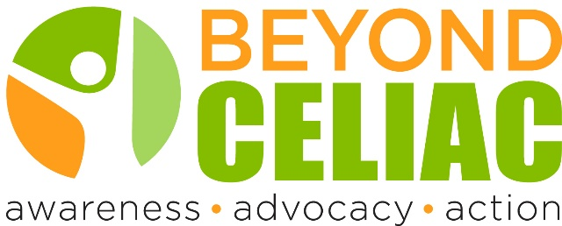
Leading Celiac Disease Experts to Explore Autoimmune Disease
Webinar will inform attendees about strategies for educating those with celiac disease about this and other autoimmune diseases
PHILADELPHIA (April 5, 2016) – Beyond Celiac will host a live webinar presentation with leading celiac disease expert Robert Anderson, BMedSc, MB, ChB, PhD, FRACP and noted author and New York Times columnist Moises Velasquez-Manoff, MA. The seminar, entitled When Your Body Turns on Itself: Understanding Autoimmune Disease, will be held Thursday, April 28, 2016 at 2:00 p.m. EDT/11:00 a.m. PDT. Also included in the panel will be Stephen Roberts, a member of the Beyond Celiac Patient and Family Advisory Council who is dually diagnosed with celiac disease and type 1 diabetes.

Beyond Celiac market research has found that most people with celiac disease do not know that it is an autoimmune disease or do not fully understand what it means to have an autoimmune disease. For many, there is great confusion between an autoimmune disease and an allergy. In addition, celiac disease has been linked to other autoimmune diseases, such as type 1 diabetes,

Program Description
The gluten-free diet fad has led people to falsely believe that celiac disease is a simple digestive condition or food preference. To combat this myth, Beyond Celiac is working to ensure that celiac disease is recognized and understood as the serious genetic autoimmune condition that it is.

Learning more about autoimmune diseases, including risk factors, signs and symptoms and why their prevalence is on the rise, is one of the most popular topics in the Beyond Celiac community. Join Beyond Celiac for a free webinar on Thursday, April 28 at 2pm EDT/11 am PDT focused on better understanding autoimmune diseases.

Panelists:
- Robert (Bob) Anderson, BMedSc, MB, ChB, PhD, FRACP, Chief Scientific Officer, ImmusanT
- Moises Velasquez-Manoff, MA, Author of An Epidemic of Absence: A New Way of Understanding Allergies and Autoimmune Diseases and Journalist appearing in The Christian Science Monitor, The New York Times Magazine, Chicago Tribune and Slate
- Stephen Roberts, Member of Beyond Celiac Patient and Family Advisory Council with both celiac disease and type 1 diabetes

For more information: http://www.beyondceliac.org/community/Free-Webinars/Upcoming-Webinars/110/

How to register: https://attendee.gotowebinar.com/register/4022227213364925441
Page two

Learning Objectives
- Define autoimmune disorders
- Discuss what is happening in the body
- Discuss some of the more common conditions
- Discuss signs and symptoms of an autoimmune disorder
- Connect to related conditions, and complications if left untreated
Program Outline

2 – 2:07pm Housekeeping – Kristin

2:08 – 2:15pm Introductions – Kristin will lead using these questions and hand over to each panelist
- What is your relationship to celiac disease or other autoimmune diseases?
- If you’re diagnosed with an autoimmune disease, when were you diagnosed?
- Do you have any family members who are also diagnosed with celiac disease or another autoimmune disease?

2:15 – 2:40 Defining Autoimmune Diseases

- Can you explain what it means to have an autoimmune disease? Why is this different than an allergic disorder or a food sensitivity?
- Why do autoimmune diseases occur?
- Why do autoimmune diseases tend to run together?
- What is the prevalence of autoimmune diseases and why are they on the rise? (e.g r​ole of genetics, the r​ole of environment, discuss Moises' experiences with the research for his book)​
- Who is at risk for developing an autoimmune disease?
- What does celiac disease have in common with other autoimmune diseases?

2:40 – 2:55 Questions from the audience sent in advance

- What risk do people with celiac disease have for developing other autoimmune diseases? What are the most common but also less common ones that still occur?
- Does the gluten-free diet help decrease the risk for developing other autoimmune diseases?
- How can I monitor my risk for other autoimmune diseases? Why is it important to monitor an autoimmune disease?
- If a person has multiple autoimmune diseases, how can you decode the source of ongoing symptoms?
- What is my risk for developing celiac disease if other autoimmune diseases run in my family?
- How are researchers collaborating with other disease areas?
- What advances are there in treating autoimmune diseases?
- Can celiac disease benefit from other autoimmune disease therapies?

2:55 – 3:00pm Closing and housekeeping items - Kristin

